# Assignment 8

Create a pool on the **DHCP Server router**, named “xyz” and follow all the requirements.

1. Client should use the DNS server with the IP address: 1.2.3.4
2. Client should use the network 192.168.10.0/24
3. Client should renew their IP address after every 3 hours
4. Make sure, Router does not respond to any BOOTP
5. Configure the Client so that it will obtain IP from DHCP server.

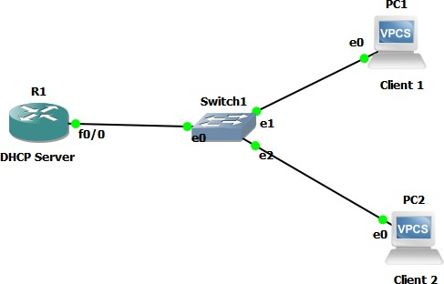

# DHCP Server Configuration

R1#sh ip int b R1#config t

R1(config)#ip dhcp pool xyz

R1(dhcp-config)#network 192.168.10.0 /24

R1(dhcp-config)#dns-server 1.2.3.4 R1(dhcp-config)#lease ?

R1(dhcp-config)#lease 0 3

R1(dhcp-config)#no ip bootp server R1(config)#int fa0/0

R1(config-if)#ip add 192.168.10.1 255.255.255.0

R1(config-if)#no shut R1(config-if)#ex R1(config)#

R1#sh ip int b

Client 1 PC1> ip dhcp

PC1> show ip

Client 2 PC2> ip dhcp

PC2> show ip

